Analysis of Problems in Linear Elasticity
with the Finite Element Method (FEM)

Bauhaus Universität Weimar, Informatik im Bauwesen

2009
Contents

1 Formulation of the FEM Solution 4
1.1 Finite Element Approximation for Linear Elasticity 4
1.2 Linear 3-Node Elements for Linear Elasticity 8
1.3 Linear 8-Node Elements in 3D for Linear Elasticity 11

Formulation of the FEM Solution
The analysis of problems in linear elasticity consists of the Finite Element approximation of the system equations with a corresponding formulation of the element equations, the influences on the model (loads), the constitutive relations (material properties) and the external support conditions.
Furthermore, a specific element must be chosen that is appropriate for the problem to be solved defining the geometry of the problem (element geometry) and the element characteristics for the model.

Finite Element Approximation for Linear Elasticity
The system equations governing the behaviour of a linear elastic two-dimensional continuum are given as follows (see for example: [3]):
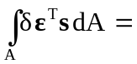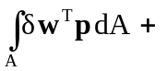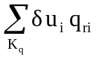+ 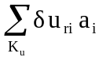
with: A center plane of the body, 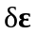variation of strain state, s state of internal forces, 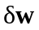 variation of displacement state within an element, p area load per unit of center plane, K_{q} set of external influences (loads), u is the vector of system nodal degrees of freedom (displacements), q_{ri} prescribed external load on boundary nodes, K_{u} set of prescribed displacements, a_{i} support force associated with prescribed displacements at nodal degrees of freedom.
The constitutive relations ( stress-strain-equations) for plane strain are defined by:
σ_{e} = 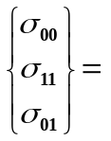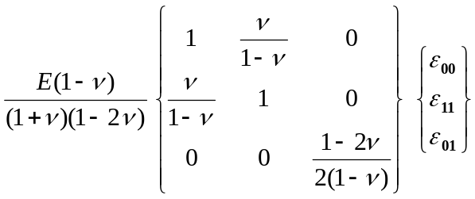
σ_{e} = E_{e} * ε_{e}
where: E is Young’s modulus of elasticity and
ν is Poisson’s ratio
Discretization over the center plane results in two sums of element integrals A_{e} over all elements:
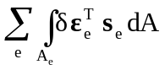= 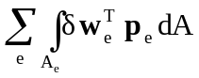+ +
Element displacements and strains are conventionally approximated via element shape function expressions S_{e} which may assume different forms depending on the choice of element:
w ≅ 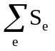 u_{e} with: u_{e} vector of nodal displacements
p ≅ b_{e} with: b_{e} vector of nodal forces
The linear strain state is defined by the vector of element strains ε_{e}:
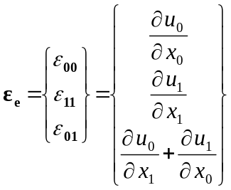 = 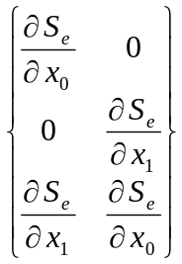 * u_{e}
ε_{e} = B_{e} * u_{e}
Assuming that we have constant stresses over the width of the body, we have
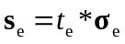 = 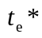 E_{e}*ε_{e} = E_{e} * B_{e} * u_{e}
where: 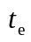is the constant thickness (width) of an element
Substituting this information into the system equation above results in the following set of equations for a general formulation in linear elasticity:
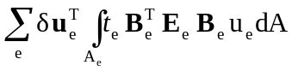= 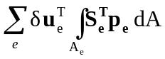 + 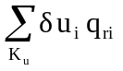 +
Depending on the type of elements and interpolation functions chosen this will result in a different set of linear equations of the form:
K_{s}u_{s} = p_{s} - q_{s}
The system matrix K_{s} is multiplied by the vector of nodal displacements u_{s} referred to as primal system vector. The Right-Hand-Side (RHS) consists of the external influences on the system referred to as load vector p_{s} (forces applied at the boundaries and inside the body) and of the support conditions on the system q_{s} referred to as dual system vector (forces resulting from predefined displacements at boundary nodes).

The system equations governing the behaviour of a linear elastic three-dimensional continuum are given as follows (see for example: [3]):
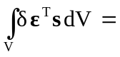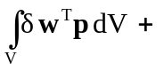+
with: V volume of the body, variation of strain state, s state of internal forces, variation of displacement state within an element, p load per unit of volume, K_{q} set of external influences (loads), u is the vector of system nodal degrees of freedom (displacements), q_{ri} prescribed external load on boundary nodes, K_{u} set of prescribed displacements, a_{i} support force associated with prescribed displacements at nodal degrees of freedom.
The constitutive relations ( stress-strain-equations) for plane strain are defined by:
σ_{e} = 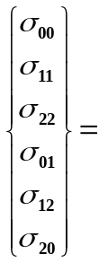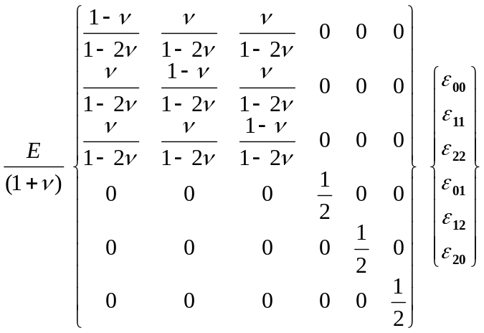
σ_{e} = E_{e} * ε_{e}
where: E is Young’s modulus of elasticity and
ν is Poisson’s ratio
Discretization over the volume results in two sums of element integrals V_{e} over all elements:
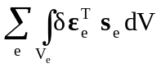= 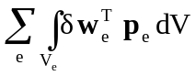+ +
Element displacements and strains are conventionally approximated via element shape function expressions S_{e} which may assume different forms depending on the choice of element:
w ≅ u_{e} with: u_{e} vector of nodal displacements
p ≅ b_{e} with: b_{e} vector of nodal forces
The linear strain state is defined by the vector of element strains ε_{e}:
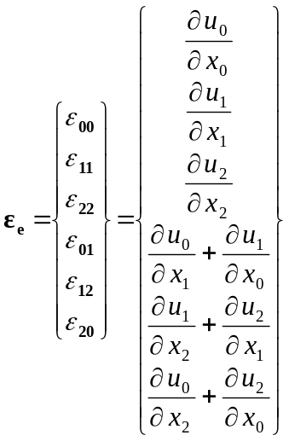 = 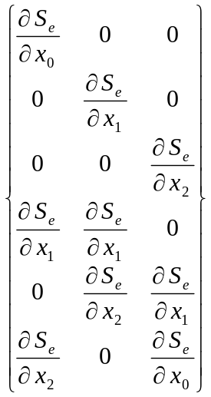 * u_{e}
ε_{e} = B_{e} * u_{e}
Substituting this information into the system equation above results in the following set of equations for a general formulation in linear elasticity:
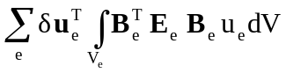= 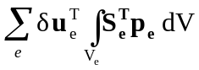 + +
Depending on the type of elements and interpolation functions chosen this will result in a different set of linear equations of the form:
K_{s}u_{s} = p_{s} - q_{s}
The system matrix K_{s} is multiplied by the vector of nodal displacements u_{s} referred to as primal system vector. The Right-Hand-Side (RHS) consists of the external influences on the system referred to as load vector p_{s} (forces applied at the boundaries and inside the body) and of the support conditions on the system q_{s} referred to as dual system vector (forces resulting from predefined displacements at boundary nodes).

Linear 3-Node Elements for Linear Elasticity
Generally, a variety of elements and approximation functions may be chosen for approximating the geometry of the model and the functional behaviour of the model.
For the purposes of this text, triangular elements were chosen to approximate the element geometry and linear functions for the element characteristics in linear elasticity. The element geometry is defined by deriving the implementation from the abstract implementation AbstractLinear3Node2D.
Physical problems of linear elasticity are defined by two degrees of freedom per node, i.e. the displacements in x₀- and x₁-direction (u_{(i)0},u_{(i)1}; u_{(j)0},u_{(j)1}; u_{(k)0},u_{(k)1}) as primal unknowns.
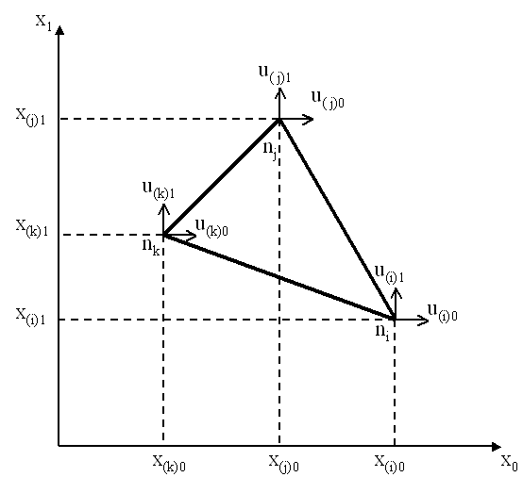  global coordinates | 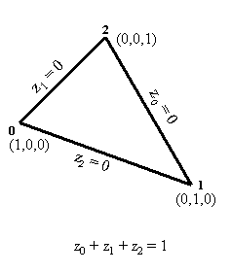  normalized triangular coordinates
The approximation of displacements and forces within an element is accomplished by the following linear interpolation using the shape functions in triangular coordinates (z₀, z₁, z₂) for all three nodes (i,j,k) in both directions (0,1):
u(z)_{e} = 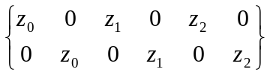 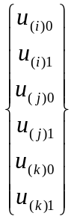
u(z)_{e} = S^{T}_{e} u_{e}
The derivative of the shape function vector S^{T}_{e} with respect to the coordinate z_{i} is called the i-th normalized derivative of the shape function vector. They are arranged rowwise in a matrix U_{z}.
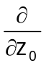(S^{T}_{e}) = 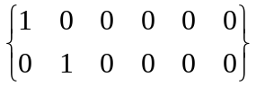
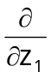(S^{T}_{e}) = 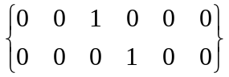 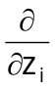(S^{T}_{e}) = U_{z}
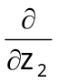(S^{T}_{e}) = 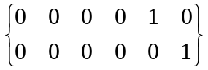 where: U_{z} is the identity matrix I
The topological mapping of normalized local onto corresponding global coordinates is defined by matrix R_{e} which maps local degrees of freedom (dof) u_{e} to global degrees of freedom u_{s}. Several local dof may be mapped to the same global dof. This mapping is implicitly handled by the FEM Framework on the basis of the system indices generated for all nodal degrees of freedom. It does not need to be performed by the user. System indices refer to the global degrees of freedom associated with each node (e.g. u_{i}) and elements with normalized coordinates are generated with reference to these nodes.
= 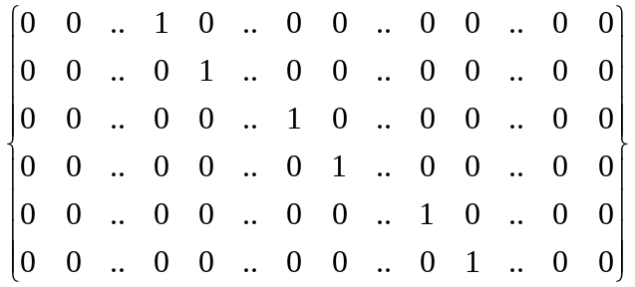 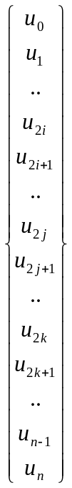
u_{e} = R_{e} u_{s}
Element strains in triangular elements define the total strain at any point within the element and can be defined by the element strain vector ε_{e} contributing to internal work.
The transformation between element strains and displacements as defined above can be applied to a general three node element as follows:
ε₀₀ = u_{0,0} = 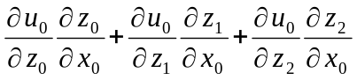
ε₁₁ = u_{1,1} = 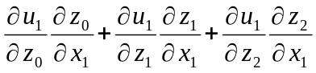
ε₀₁ = u_{0,1} + u_{1,0} = 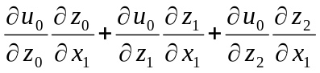 + 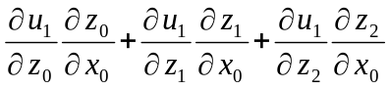
The derivatives of the element displacements with respect to the normalized triangular coordinates can be derived from the equation u(z)_{e}= S^{T}_{e} * u_{e} defined above, where
with: 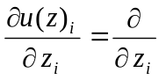 (S^{T}_{e} * u_{e}) = U_{z} u_{e} = u_{e}
= 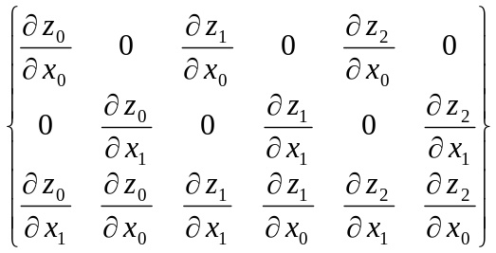
substituting the derivatives of the shape function vector from above:
S_{xe} =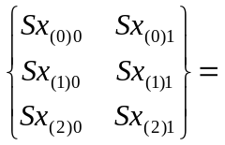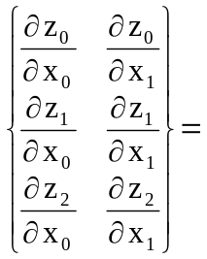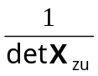*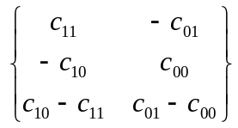
ε_{e} = 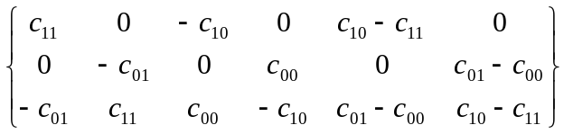
ε_{e} = B_{e} * u_{e}
Element matrices are determined by evaluating for each element the integrals:
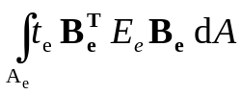
In case of a linear triangle, the element strain displacement matrix B_{e} and the value of the determinant are independent of the normalized coordinates z_{i} and thus constant at each point within the triangle. The element thickness t_{e} was also assumed to be constant. The integrals can therefore be evaluated analytically for each element.
k_{e} = t_{e} B^{T}_{e} E_{e} B_{e} area_{e}
In general, integration of element matrices is accomplished numerically, i.e. by evaluating the individual contributions at each Gauss point, by summing up contributions for all Gauss points and by multiplying the results with the corresponding Gauss weights. Thus, evaluation at three Gauss point and application of Gauss weight 1/3 would result in the same constant value of the shape function derivatives and the determinant.

Linear 8-Node Elements in 3D for Linear Elasticity
Elements with eight nodes and a linear variation of coordinate functions in each direction may be chosen to approximate the element geometry and element characteristics in elasticity analysis. The element geometry with the shape function definitions, the shape function derivatives and the Jacobian is defined by deriving the implementation from the abstract implementation AbstractLinear8Node3D.
Physical problems of linear elasticity are defined by three degrees of freedom per node, i.e. the displacements at the nodes i,j,k,l,m,n,o,p (e.g. u_{0(i)}, u_{1(i)}, u_{2(i)}) as primal unknowns).
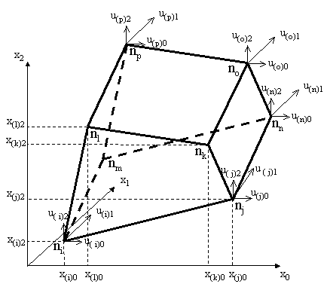  global coordinates | 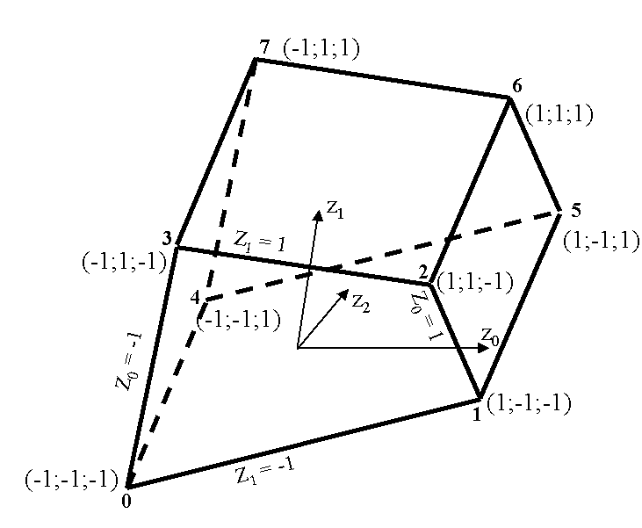  normalized coordinates
The approximation of temperatures and heat streams within an element is accomplished by linear interpolation using the shape functions in global coordinates (z₀, z₁, z”) for all eight nodes (0,1, 2, 3, 4, 5, 6, 7) in all directions (0,1,2):
u(z)_{e} = S^{T}_{e} u_{e}
where: u_{e} is the vector of nodal displacements at 8 nodes in 3 directions (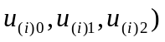 and S^{T}_{e} is the (3*24) matrix of shape function vectors s(z) in all 3 directions
The topological mapping of normalized onto corresponding global coordinates is defined by matrix R_{e} which maps local field variables u_{e} at all nodes to global field variables u_{s}. This mapping is implicitly handled by the FEM Framework on the basis of the system indices generated for all nodal degrees of freedom. It does not need to be performed by the user. System indices refer to the global degrees of freedom associated with each node (e.g. u_{i}) and elements with normalized coordinates are generated with reference to these nodes.
u_{e} = R_{e} u_{s}
Element strains in 3D elements define the total strain at any point within the element and can be defined by the element strain vector ε_{e} contributing to internal work.
The transformation between element strains and displacements as defined above can be applied to a general eight node element as follows:
ε₀₀ = u_{0,0} =
ε₁₁ = u_{1,1} =
ε₂₂ = u_{2,2} = 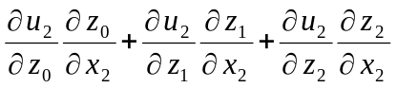
ε₀₁ = u_{0,1} + u_{1,0} = +
ε₁₂ = u_{1,2} + u_{2,1} = 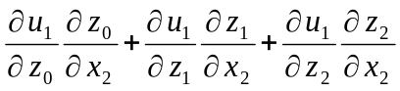 + 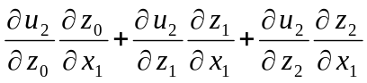
ε₂₀ = u_{0,2} + u_{2,0} = 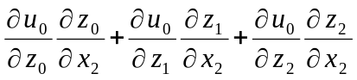 + 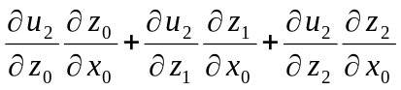
with: 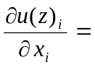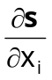u_{e} = S_{xe} u_{e}
and substituting the derivatives of the shape function vector S_{xe} from above for each node (indicated by brackets) we get for the first 2 of a total of 8 nodes:
ε_{e} = 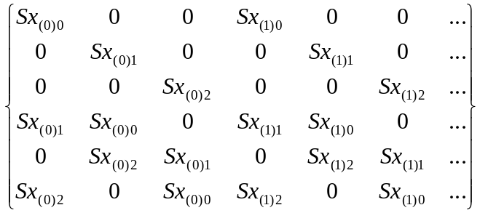*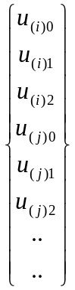
ε_{e} = B_{e} * u_{e}
Element matrices are determined by evaluating for each element the integrals:
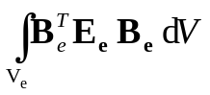
dV = dx₀ dx₁ dx₂ = det X_{z} dz₀ dz₁ dz₂
In case of a linear trilateral, the element strain displacement transformation matrix B_{e} and the value of the determinant are evaluated numerically by Gaussian integration. For this purpose, the values of matrix B_{e} are evaluated at corresponding Gauss points and multiplied by associated Gauss weights. Integration over the volume of the elements is carried out in normalized coordinates.
Thus, element matrices may be evaluated by the sum over the Gauss points for the product:
k_{e} = 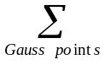B^{T}_{e} * E_{e}*B_{e} * det X_{z}
where : E_{e} is constant over the element and
the values of B_{e} and det X_{z} are evaluated at each Gauss point
For the case of the linear element with 8 nodes, an order of integration of 3×3x3 is sufficient. The corresponding Gauss points p(z₀, z₁, z₂) are defined in all 3 directions by the 3 normalized coordinates:
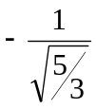 0 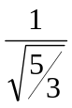
and the corresponding Gauss weights are:
This can be shown for the 3x3 Gauss points in a plane in direction z₂ = :
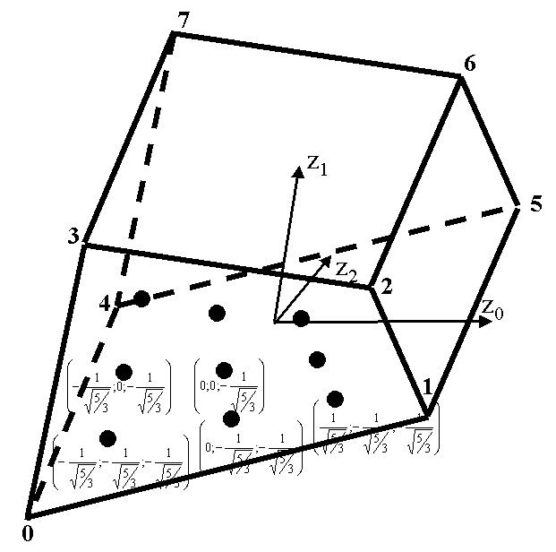  normalized coordinates | with the associated Gauss weights equal to  in both directions

